**1st Annual Wright**

**4-H Sewing Conference**

* The structure of the Sewing Conference reflects our hope to make the days flow more smoothly for both volunteers and sewers! With the guidance of Master Sewers, youth will receive assistance to work on sewing projects while gaining the skills to complete their project.
* All level A & B sewers will be required to choose from the approved patterns picked by the Fabric and Fashion Conference Committee to sew at the conference. The fabric may be picked by the member within the recommended fabric guidelines.

**Friday, May 17th – Mandatory Pattern & Fabric Approval/Cutting and Fitting**

1:00 p.m. to 4:00 p.m. – Wright Library Conference Room

**NO SEWING will be allowed during these times. There will be no guarantee of completing cutting and fitting.**

**Tuesday, May 28th to Thursday May 30th – Sewing**

***Beginner sewers will begin with a Beginner’s sewing Lesson.***

9:00 a.m. to 4:00 p.m. – Wright Library Conference Room

**Members are expected to help cleanup before leaving!**

***Only the Conference Room will be available, therefore if non-sewers are disruptive or distracting, they will be asked to leave.***

**REGISTRATION DEADLINE: Friday, May 17th, 2024**

Sewing Conference Packets including registration forms, levels, and

approved patterns can be found online at

<https://wyoextension.org/campbellcounty/4h-youth-development/expressive-arts-cake-visual-arts-crocheting/sewing/>

Or Contact Makala Riley at the Extension Office at 682-7281

**Office Check-List**

**OFFICE USE ONLY**

* Registration Form
* $10.00 paid
* Pattern/Fabric Approved

4-H Member Registration Form for

Registration Deadline:

Friday, May 17th, 2024

## 2024 Wright Sewing Conference

# May 28th - 30th

**Total Cost: $10.00**

Member’s name: _____________________________________________ Age: _________

Parent or Guardian’s name: ______________________________Years in F&F: _________

Cell #: ________________________ E-mail address: ______________________________

I will need a sewing machine furnished. _____ yes _____ no

I will be sharing equipment with a sibling or friend. _____ yes _____no

We have 4-H sewing machines available for use during Conference. These will be available on a first come first serve basis, based on application return dates.

There is fabric available at the Extension office if anyone wants any.

All sewers **must** choose a pattern from the approved list at the back of this packet.

ALL levels must attend the Pattern and Fabric Approval –

Friday, May 17th from 1:00-4:00 pm – Wright Library Conference Room

*All Conference sewers must have their patterns and fabric approved to sew at Sewing Conference!*

Parent Registration Form for

If you can assist in any of the ways listed below, please return by Friday May 17th.

Name: ____________________________________ Cell Phone:________________________

I can help with the sewing conference by:

_____ Being available on (which days) from the hours of _____________________ to help.

_____I will help my own 4-H member. OR _____I am able to help other 4-H members.

**\* Please indicate which day and session**

_____Friday Afternoon

_____Tuesday Morning _____Tuesday Afternoon

_____ Wednesday Morning _____Wednesday Afternoon

_____Thursday Morning _____Thursday Afternoon

**THANK YOU FOR YOUR SUPPORT!**

**Name ___________________________ Date__________________________**

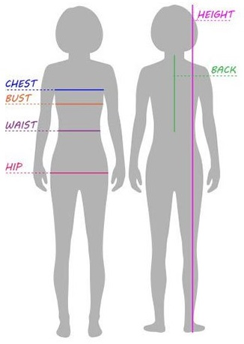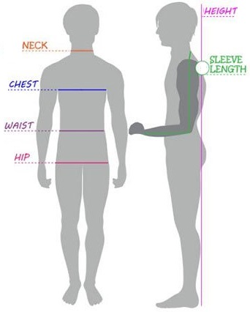

Bust _____________________ Sleeve Length ___________________

Waist ____________________ Neck/Nape ______________________

Hip ______________________ Nape to Floor____________________

Height _________________________

**Level A, B, Material Types**

Solid Colors or Small Prints

No Plaid, Striped, or Big Patterned Materials

No Knit of Any Kind

No Fleece!

***Woven Fabric Only***

Cotton

Cotton/Polyester Blend

Flannel

**PRE-WASH ALL FABRIC**

Fabric examples are available at the Extension Office

MC900280975[1]

**Sewing Conference Supply List**

Closed toe shoes- covering your feet

Sewing Machine and Accessories including Manual

Sewing Box or Bag- to hold your supplies

Fabric- Remember to Pre-Wash

Pattern

Notions- such as elastic and zippers

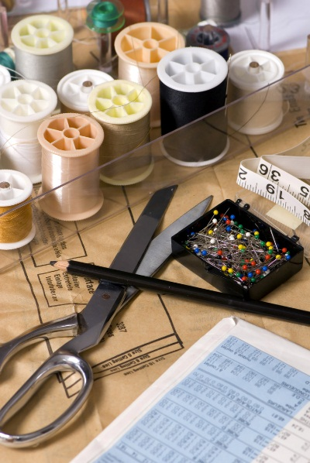Thread

Fabric and Paper Scissors

Thread Nippers

Seam Ripper

Measuring Tape

Seam Gauge

Pins and Pin Cushion

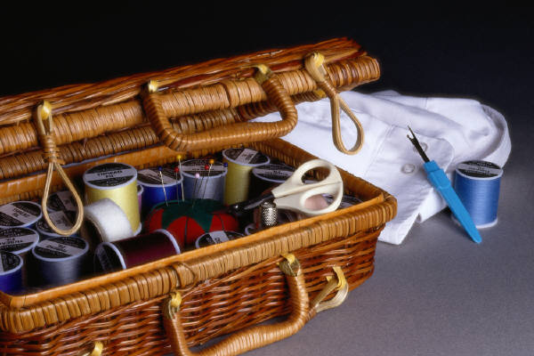Hand Needles

Needles

Ponytail Holders

Pencil

C:\Documents and Settings\User\Local Settings\Temporary Internet Files\Content.IE5\IZ0R9HHU\MC900435993[1].wmf

**2024 Approved**

**Sewing Patterns**



