3rd Annual Wright
4-H Sewing Conference

- The structure of the Sewing Conference reflects our hope to make the days flow more smoothly for both volunteers and sewers! With the guidance of Master Sewers, youth will receive assistance to work on sewing projects while gaining the skills to complete their project.
- All level A, A+ & B sewers will be required to choose from the approved patterns picked by the Fabric and Fashion Conference Committee to sew at the conference. The fabric may be picked by the member within the recommended fabric guidelines.
- All other members that are sewing at Conference must have their pattern and fabric pre-approved by the Fabric and Fashion Conference Committee.

Friday April 17th Mandatory Pattern & Fabric Approval
Packet must be turned into Extension Office via in person/email format.
Pattern must be approved via email/or with packet.
A fabric swatch should be submitted with your packet or Makala will be available during the hours of 10am-noon at the Wright Library to drop it off to her.

May 1st, 8th and 15th – Sewing
Wright Library Conference Room
10am- noon - Advanced
1pm-4pm – Beginners
*Advanced Sewists can continue sewing in the afternoons, but will receive minimal assistance
1st year sewists will begin with a Basic Sewing Lesson
Members are expected to help clean up before leaving!
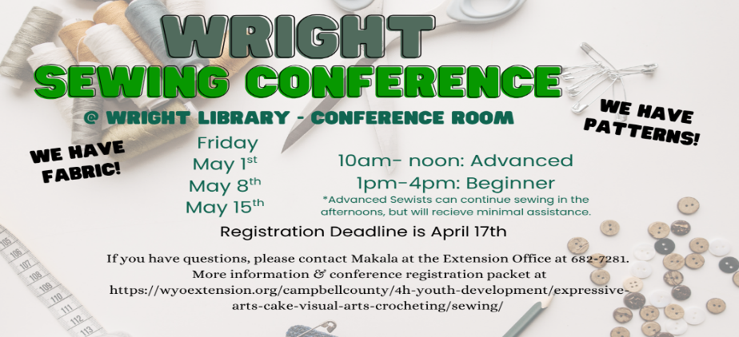
Only the Conference Room will be available, therefore if non-sewers are disruptive or distracting, they will be asked to leave.

REGISTRATION DEADLINE: Friday, April 17th 2026
Sewing Conference Packets including registration forms, levels, and
approved patterns can be found online at
https://wyoextension.org/campbellcounty/4h-youth-development/expressive-arts-cake-visual-arts-crocheting/sewing/
Or Contact Makala Riley at the Extension Office at 682-7281
Registration Deadline:
Friday, April 17th 2026
Office Checklist
OFFICE USE ONLY
- Registration Form
- $10.00 paid
- Pattern/Fabric Approved

4-H Member Registration Form for

2026 Wright Sewing Conference

May 1st, 8th and 15th
Total Cost: $10.00

Member’s name: ___________________________________________ Age: _________

Parent or Guardian’s name: ______________________________Years in F&F: _________

Cell #: ________________________ E-mail address: ______________________________

*Please indicate which days you will be attending. Be sure to acknowledge the level groups and times that are designated and sign up accordingly.

Please indicate your Pattern Number here: _____________
If you have a question as to which level you are at under the guidelines, call Makala at
307-682-7281
 | Levels A, A+ or B  Mornings | Levels C, D Afternoons
May 1st | Mandatory Beginner Sewer Class
May 8th
May 15th

I will need a sewing machine furnished. _____ yes _____ no

I will be sharing equipment with a sibling or friend. _____ yes _____no

We have 4-H sewing machines available for use during Conference. These will be available on a first come first serve basis, based on application return dates.
There is fabric available at the Extension office if anyone wants any.
Level A, A+, B: will sew a 4-H Leader chosen pattern, but may choose their own fabric
Levels C, D, +: pattern and fabric choice must be consistent with the sewing level
ALL levels must have their Pattern and Fabric Pre-Approved by Friday, April 17th

Parent Registration Form
If you can assist in any of the ways listed below, please return by Friday April 17^{th.}

Name: ____________________________________ Cell Phone: ________________________

I can help with the sewing conference by:
_____ Being available on (which days) from the hours of _____________________ to help.
_____I will help my own 4-H member. OR _____I can help other 4-H members.
I can help on: May 1st May 8th May 15th In the: AM PM
Name ___________________________ Date__________________________

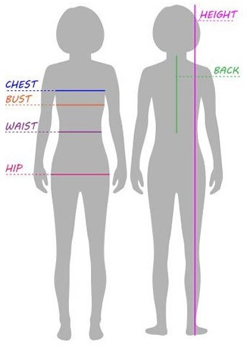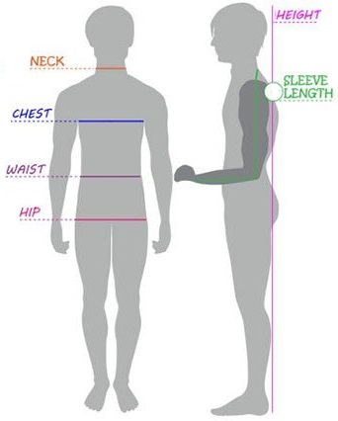

Bust _____________________ Sleeve Length ___________________
Waist ____________________ Neck/Nape ______________________
Hip ______________________ Nape to Floor____________________
Height _________________________

Level A, B, Material Types

Solid Colors or Small Prints

No Plaid, Striped, or Big Patterned Materials

No Knit of Any Kind

No Fleece!

Woven Fabric Only

Cotton

Cotton/Polyester Blend

Flannel

PRE-WASH ALL FABRIC

Fabric examples are available at the Extension Office

Sewing Conference Supply List

Closed toe shoes- covering your feet
Sewing Machine and Accessories including Manual
Sewing Box or Bag- to hold your supplies
Fabric- Remember to Pre-Wash
Pattern
Notions- such as elastic and zippers
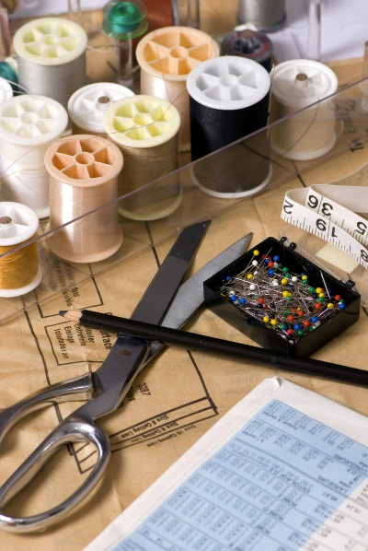
Thread
Fabric and Paper Scissors
Thread Nippers
Seam Ripper
Measuring Tape
Seam Gauge
Pins and Pin Cushion
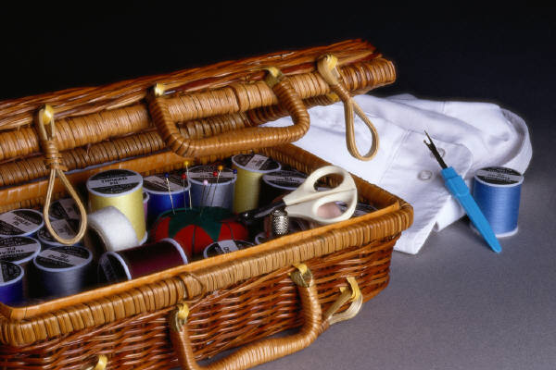
Hand Needles
Needles
Ponytail Holders
Pencil

2026 Approved
Sewing Patterns

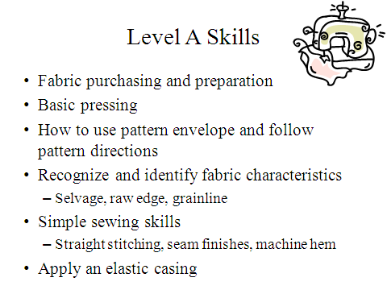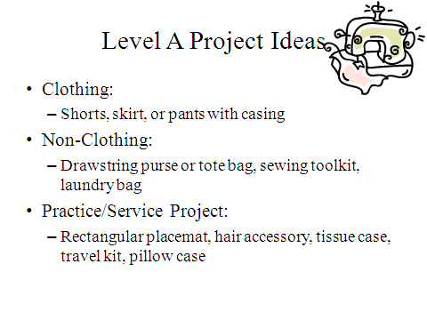
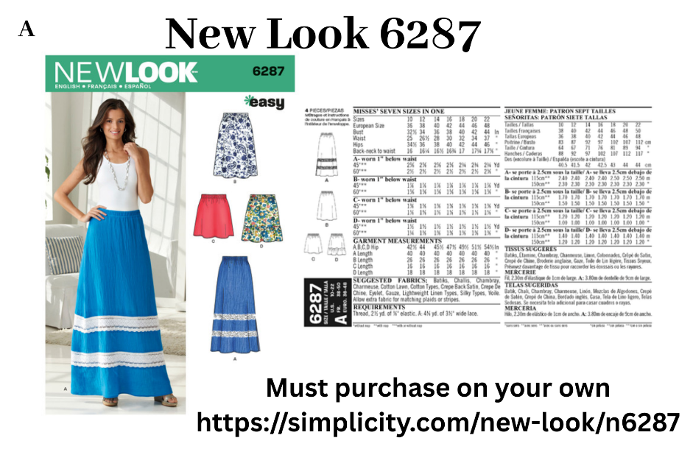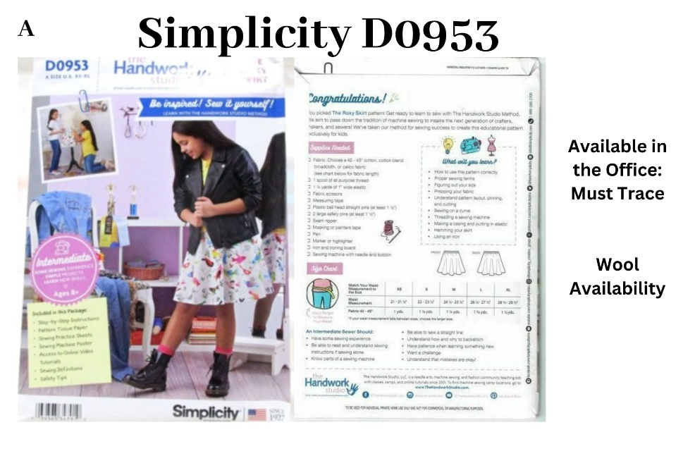
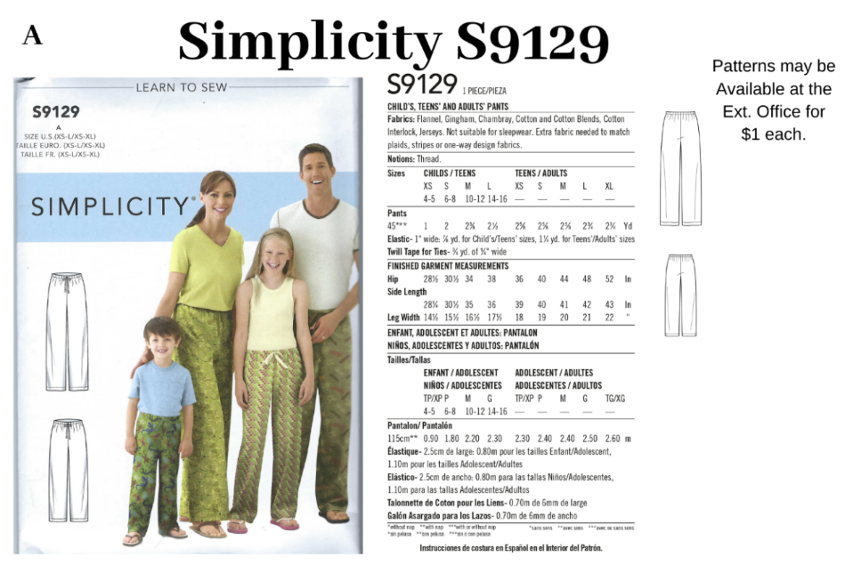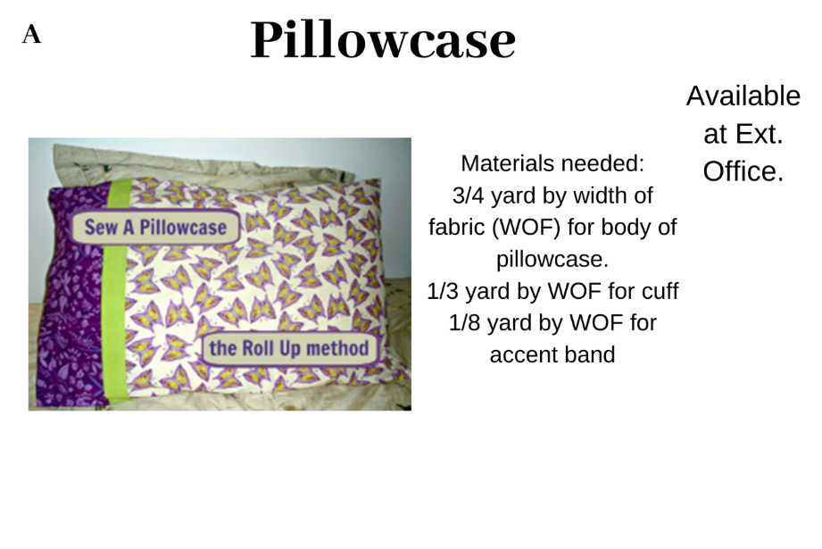

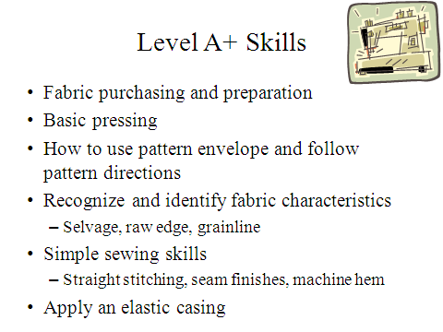

∙ Sew in pockets
