34th Annual Campbell County
4-H Sewing Conference

- The structure of the Sewing Conference reflects our hope to make the days flow more smoothly for both volunteers and sewers! With the guidance of Master Sewers, youth will receive assistance to work on sewing projects while gaining the skills to complete their project.
- All level A, A+, & B sewers will be required to choose from the approved patterns picked by the Fabric and Fashion Conference Committee to sew at the conference. The fabric may be picked by the member within the recommended fabric guidelines.
- All other members that are sewing at Conference must have their pattern and fabric pre-approved by the Fabric and Fashion Conference Committee.

Friday May 22nd – Registration Deadline and Mandatory Pattern & Fabric Approval
1:00 p.m. to 4:00 p.m. – GAMB, Cottonwood Room
NO SEWING will be allowed during these times.

Friday May 29th –Mandatory Cutting and Fitting
1:00 p.m. to 4:00 p.m. – GAMB, Cottonwood Room
NO SEWING will be allowed during these times.

Monday, June 1st to Friday June 5th – Sewing.
Beginner sewers class on Monday, June 9th from 9a.m.-noon. We will go over the basics. All 1st year attendees must attend!
Only the Cottonwood Room will be available, therefore if non-sewers are disruptive or distracting, they will be asked to leave.

9:00 a.m. – 12:00 p.m. - Level A, A+, B Sewers
1:00 p.m. – 5:00 p.m. - Level C, D Sewers
Members are expected to help clean up before leaving!
REGISTRATION DEADLINE: Friday, May 22nd by 1 pm
Sewing Conference Packets including registration forms, levels, and
approved patterns can be found online at
https://wyoextension.org/campbellcounty/4h-youth-development/expressive-arts-cake-visual-arts-crocheting/sewing/
Or Contact Makala Riley at the Extension Office at 682-7281
Registration Deadline:
Friday, May 22, 2026
Office Checklist
OFFICE USE ONLY
- Registration Form
- $10.00 paid
- Pattern/Fabric Approved

4-H Member Registration Form for

2026 Sewing Conference

June 1st-5th
Total Cost: $10.00

Member’s name: __________________________________________ Age: _________

Parent or Guardian’s name: _____________________________ Years in F&F: _________

Cell #: ________________________ E-mail address: ______________________________

I will attend the pre-conference cutting out/fitting session on Friday May 29th, 1:00 p.m. to 4:00 pm ____ (initials)

_____I wish to attend the beginners sewing class on Monday, June 1st from 9:00 am to noon
This class is required for 1st year sewers and encouraged for others as a refresher!

*Please indicate which days you will be attending. Be sure to acknowledge the level groups and times that are designated and sign up accordingly.

Please indicate your Pattern Number here: _____________
If you have a question as to which level you are at under the guidelines, call Makala at
307-682-7281
 | Levels A, A+ or B  Mornings | Levels C, D Afternoons
Monday, June 1st | Mandatory Beginner Sewer Class
Tuesday, June 2nd
Wednesday, June 3rd
Thursday, June 4th
Friday, June 5th

I will need a sewing machine furnished. _____ yes _____ no

I will be sharing equipment with a sibling or friend. _____ yes _____no

We have 4-H sewing machines available for use during Conference. These will be available on a first come first serve basis, based on application return dates.
There is Fabric available at the Extension Office if anyone wants any!
Level A, A+, B: will sew a 4-H Leader chosen pattern, but may choose their own fabric
Levels C, D, +: pattern and fabric choice must be consistent with the sewing level
ALL levels must attend the Pattern and Fabric Approval –
Friday May 22nd from 1:00-4:00 pm – GAMB, Cottonwood Room
All Conference sewers must have their patterns and fabric approved to sew at Sewing Conference!
Parent Registration Form for
2026 Sewing Conference

June 1st-5th

If you can assist in any of the ways listed below, please return by Friday May 29th^{th}

Name: ________________________________________________________________

Home Phone: ________________________ Cell Phone: ________________________

I can help with the sewing conference by:
_____ Being available on (which days) from the hours of __________ to help
_____I will help my own 4-H member
_____I can help other 4-H members
_____Providing fruit, vegetables, or crackers for the 4-Her’s at break time.

* Please indicate which day and session

_____Monday Morning _____Monday Afternoon
_____Thursday Morning _____Tuesday Afternoon
_____ Wednesday Morning _____Wednesday Afternoon
_____Thursday Morning _____Thursday Afternoon
_____Friday Morning _____Friday Afternoon

THANK YOU FOR YOUR SUPPORT!

Name ___________________________ Date__________________________

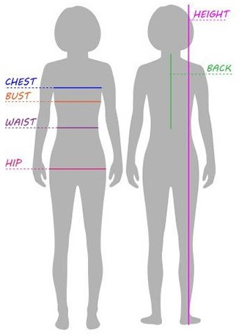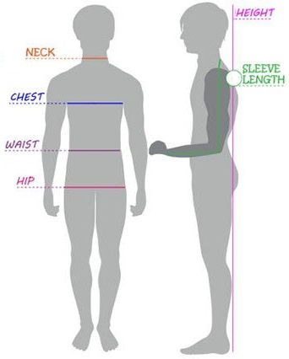

Bust _____________________ Sleeve Length ___________________
Waist ____________________ Neck/Nape ______________________
Hip ______________________ Nape to Floor____________________
Height _________________________

Level A, B, C Material Types

Solid Colors or Small Prints

No Plaid, Striped, or Big Patterned Materials

No Knit of Any Kind

No Fleece!

Woven Fabric Only

Cotton

Cotton/Polyester Blend

Flannel

PRE-WASH ALL FABRIC

Some Fabric is available at the Extension Office

Sewing Conference Supply List

Closed toe shoes- covering your feet
Sewing Machine and Accessories including Manual
Sewing Box or Bag- to hold your supplies
Fabric- Remember to Pre-Wash
Pattern
Notions- such as elastic and zippers
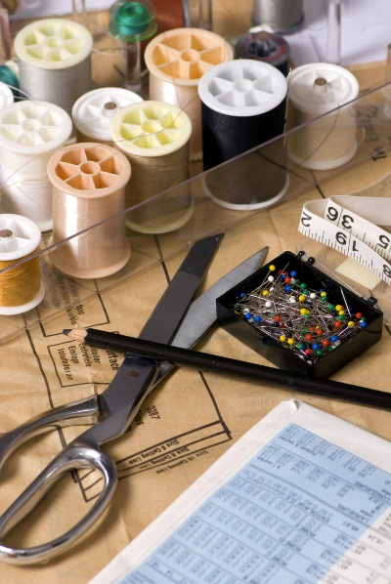
Thread
Fabric and Paper Scissors
Thread Nippers
Seam Ripper
Measuring Tape
Seam Gauge
Pins and Pin Cushion
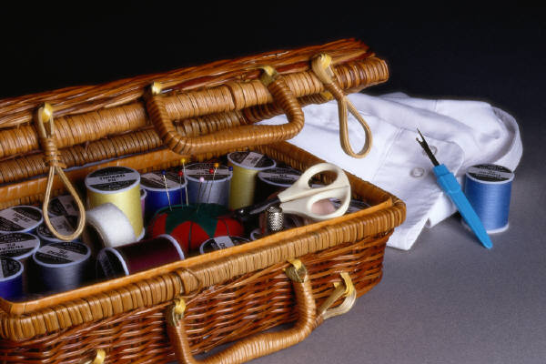
Hand Needles
Needles
Ponytail Holders
Pencil

2026 Approved
Sewing Patterns

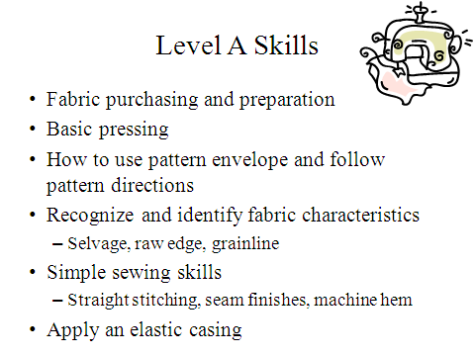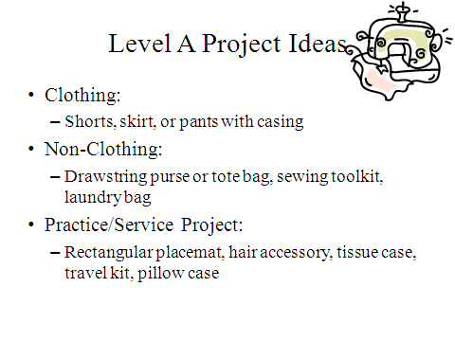
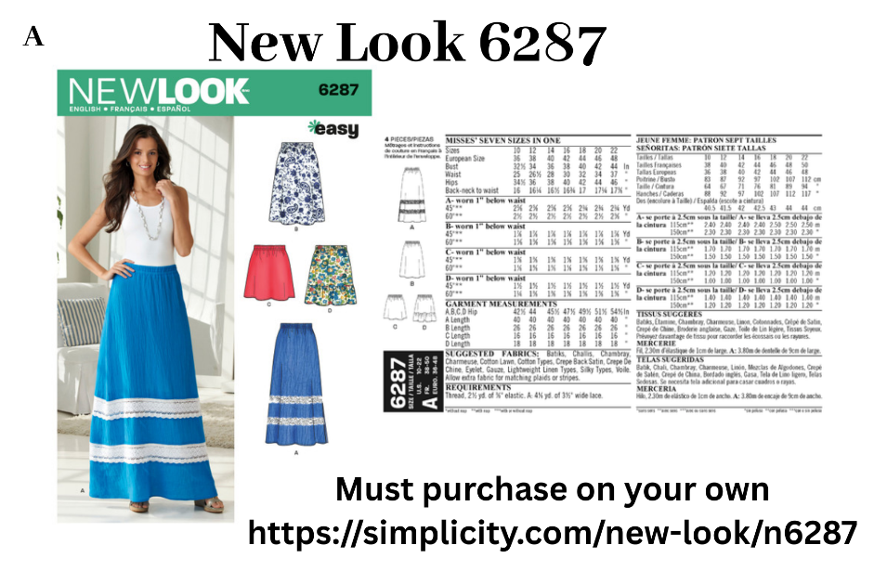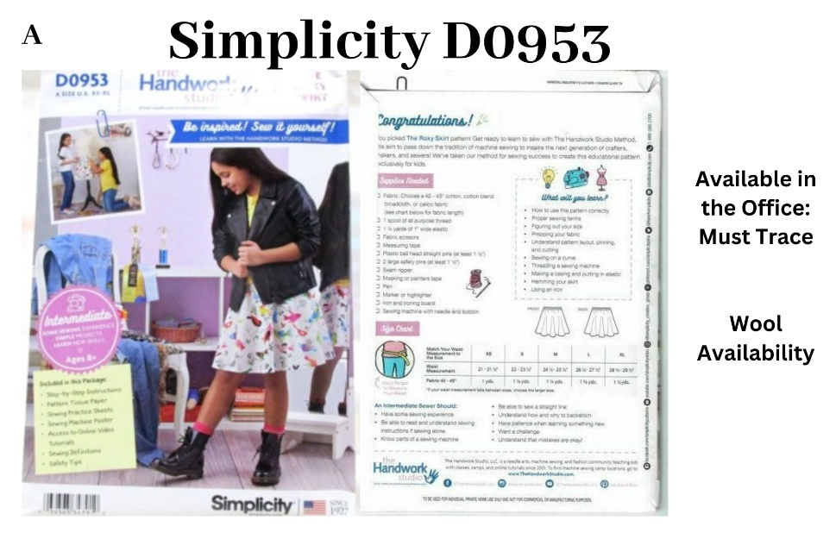
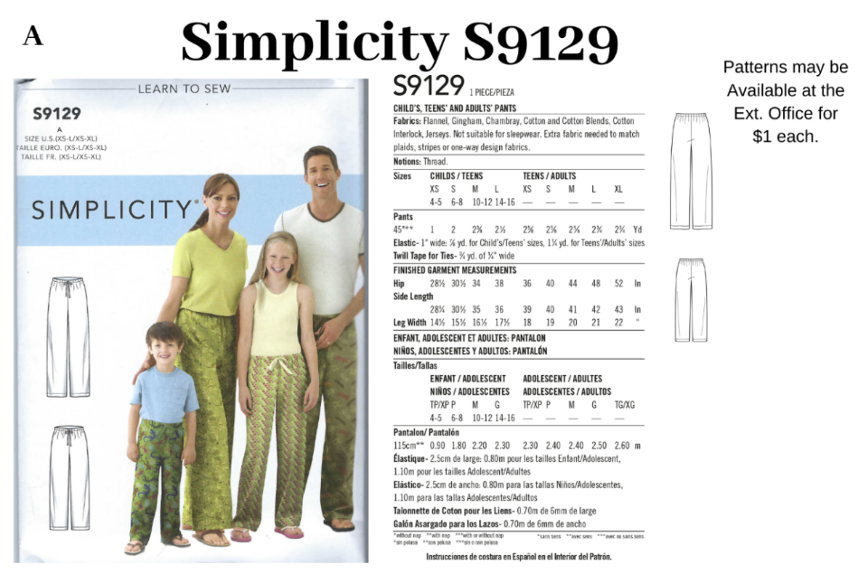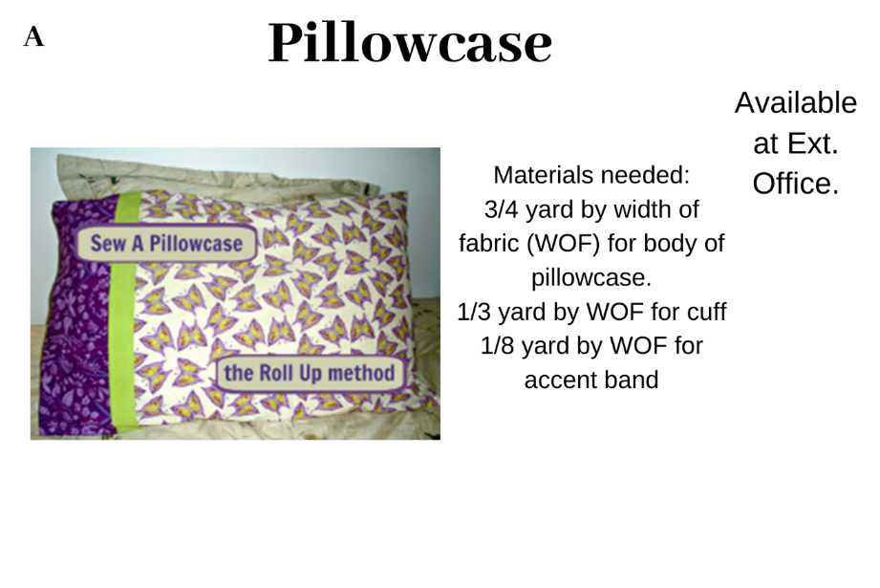

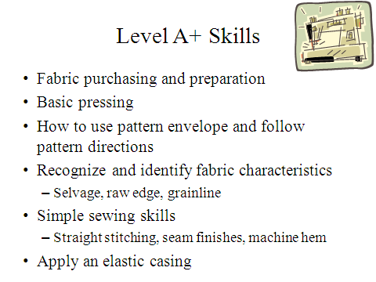

∙ Sew in pockets
