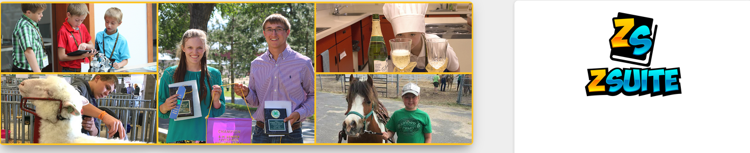
New Online Record Books: Key Take-Aways

- Requirements and Expectations for each section are the same as the old version.

- Instead of having eight sections, with Section 1 being the project report and Sections 2-8 showing your involvement in the 4-H program, there are now two reports: Project Reports with five sections, and a 4-H Year Involvement Report with seven sections
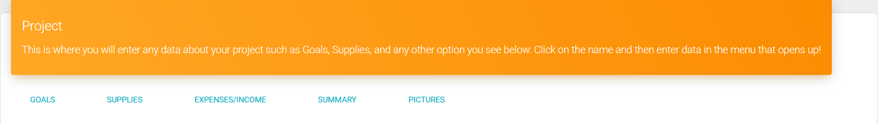
  - You will complete a Project Report for every 4-H project you are enrolled in for the year
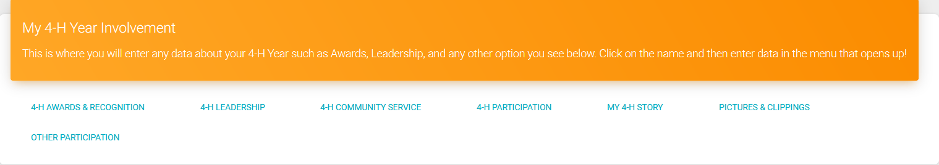
  - You will complete one 4-H Year Involvement Report and add to it every year you are in 4-H
  - Both your Project Reports and 4-H Year Involvement Report will need to be submitted to submit a complete Record Book

- Project Categories: When creating a Project Report, you must select the category your project falls under. These categories are listed on the Wyoming 4-H website for reference, but you can also just click around until you find the right one.
- Pictures: You can now submit 9 photos in your 4-H Year Involvement Report and 9 photos in each Project Report
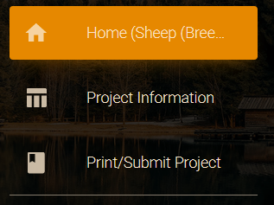
To Submit Your Record Book:
Click on “Print/Submit” in the menu on the left-hand dashboard for BOTH the Project Reports and the 4-H Year Involvement Report. Print both and put both in your usual Record Book cover and submit to the Carbon County Extension Office by September 15th!

