Adding an Episode to Anchor

- Create an account or sign in at https://anchor.fm/login
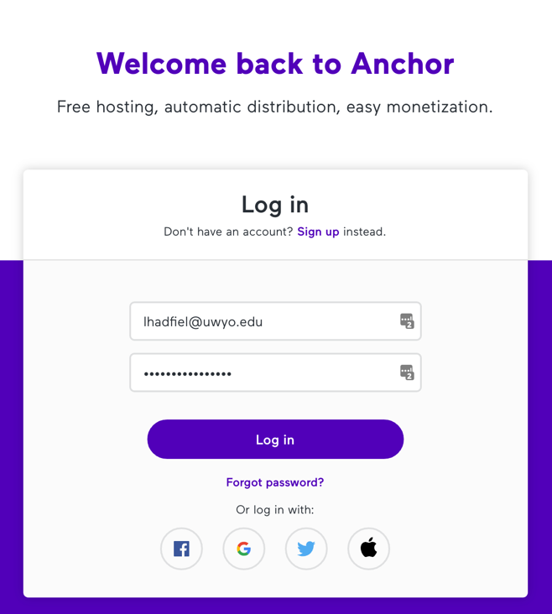

- On the Dashboard you can change the description and get a link to the public site. You will see get started tips until you have episodes, then analytics will be here.
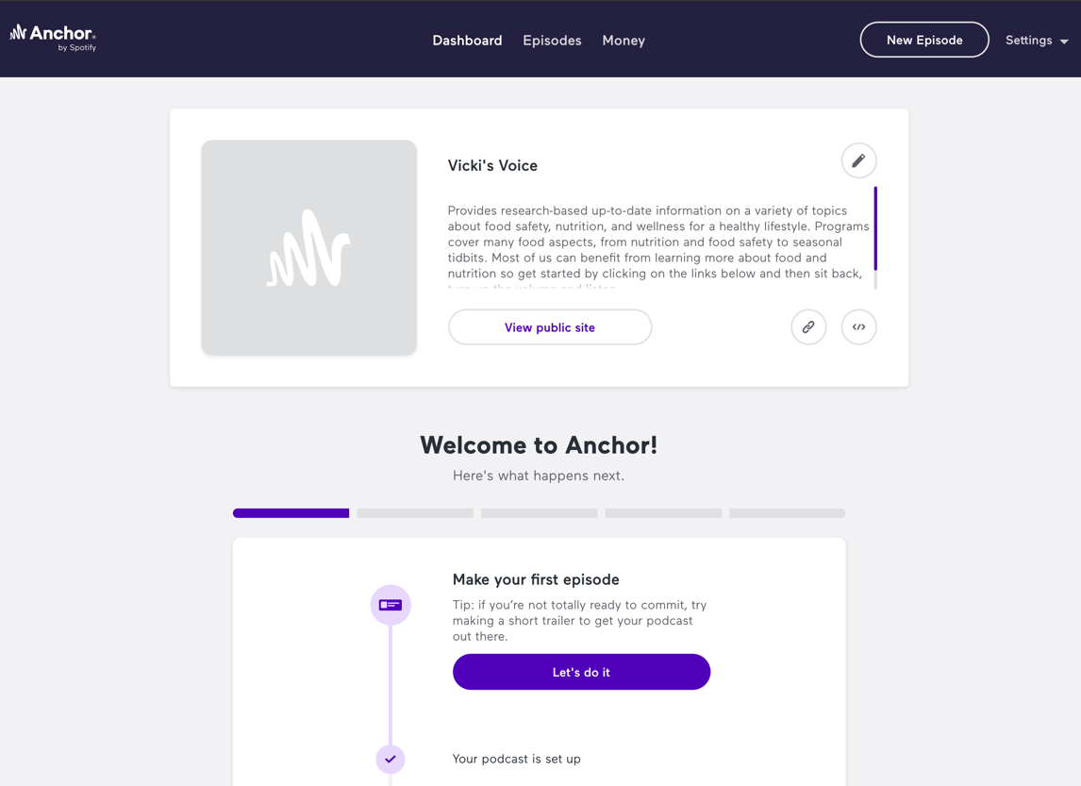

- Click Episodes at the top to see your list of episodes. Click Create New here or choose New Episode from the top right.
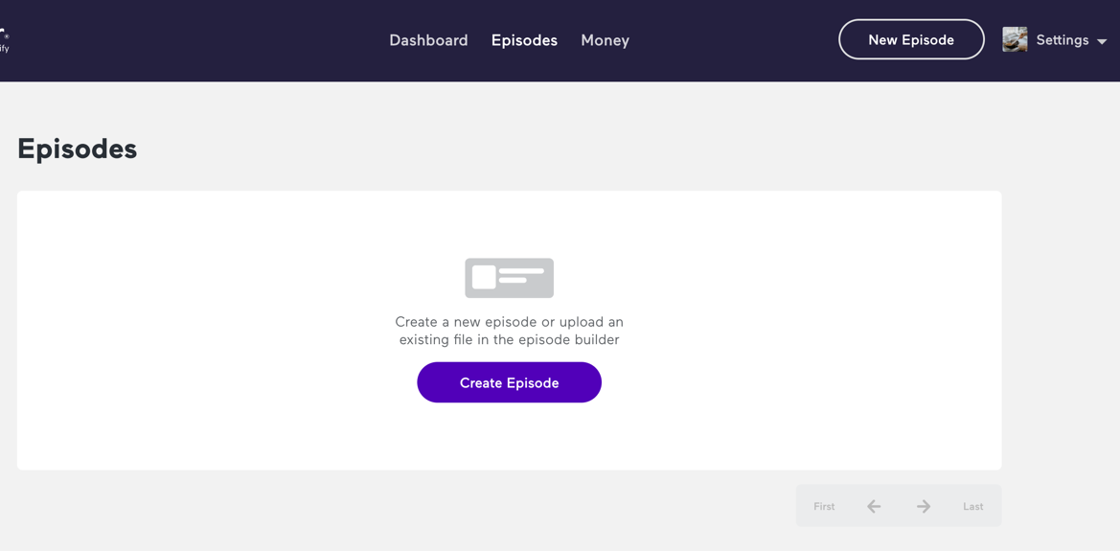

- Record directly into the browser or add media from your computer. You can add music and transitions to build the show or upload a complete episode. Click Save Episode when finished.
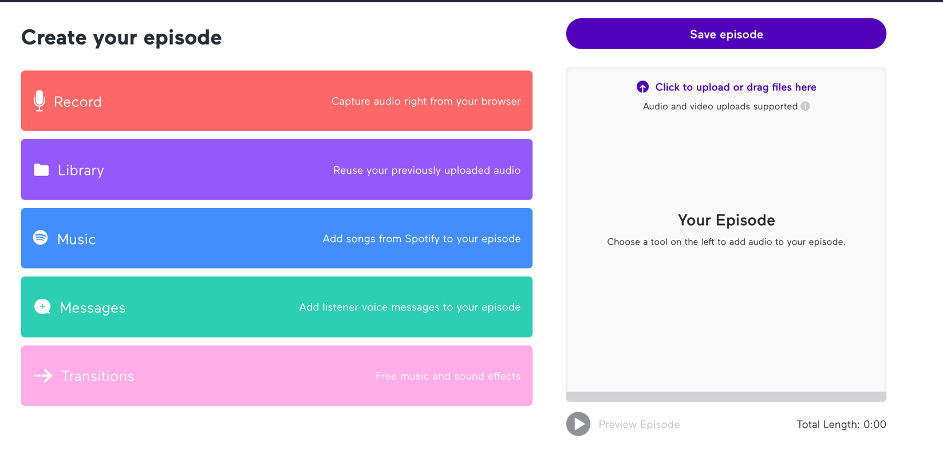

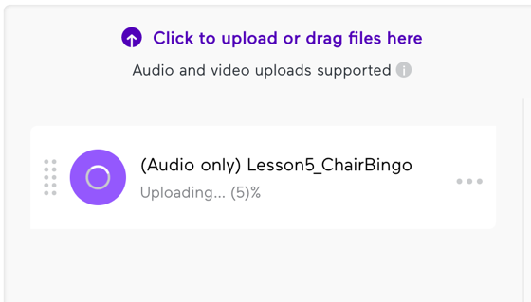

- Add a title and description. You can include links and format the text. Choose to publish now or schedule a date and time. Save as draft at the top or continue to the bottom to publish.
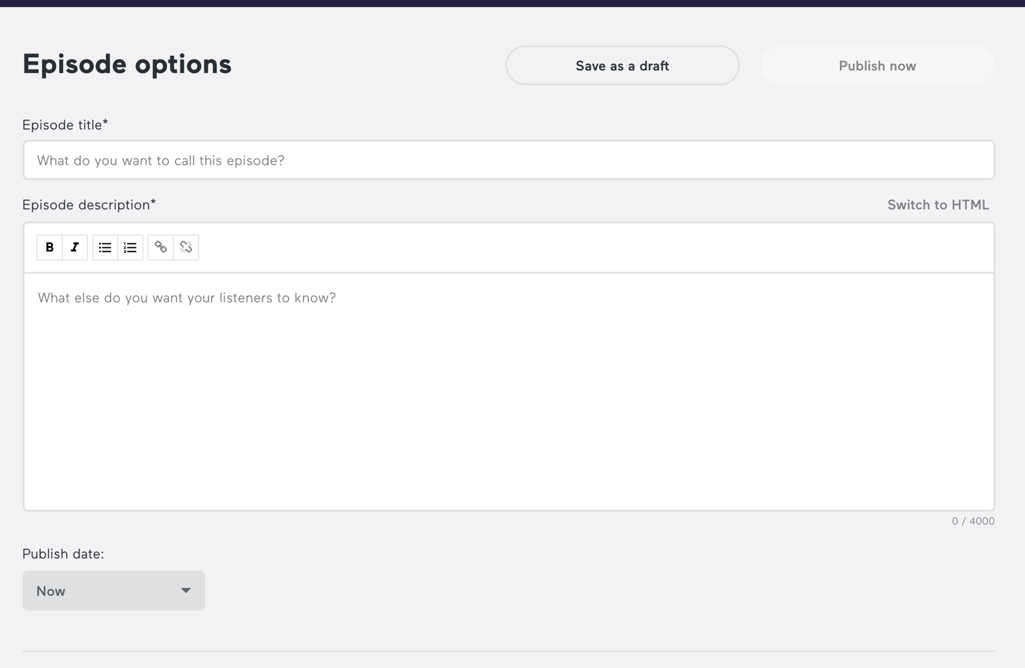

- Add optional information like season and episode number. You can upload cover art here or in Settings.
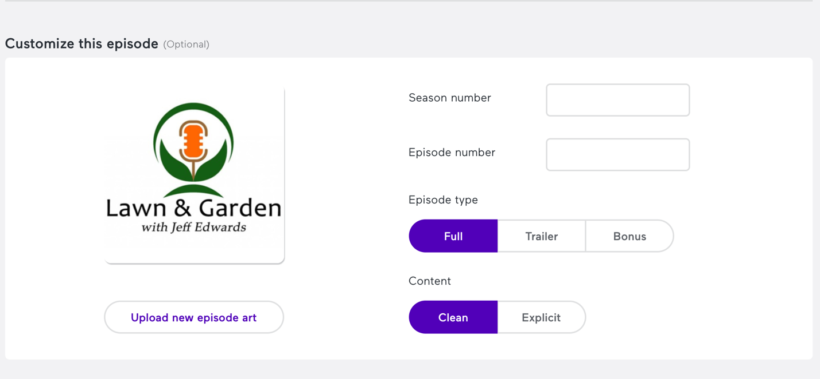

- Scroll to the top to save a draft or publish/schedule the episode. If you are unable to publish, make sure an audio file correctly uploaded.

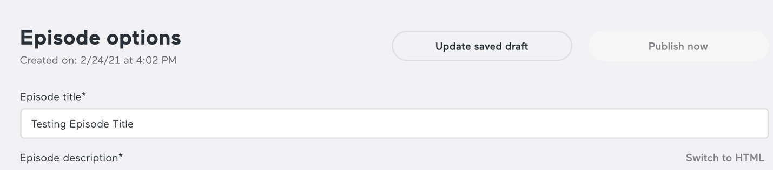

- Click Episodes at the top again to see your new episode or a list if you have multiple episodes.
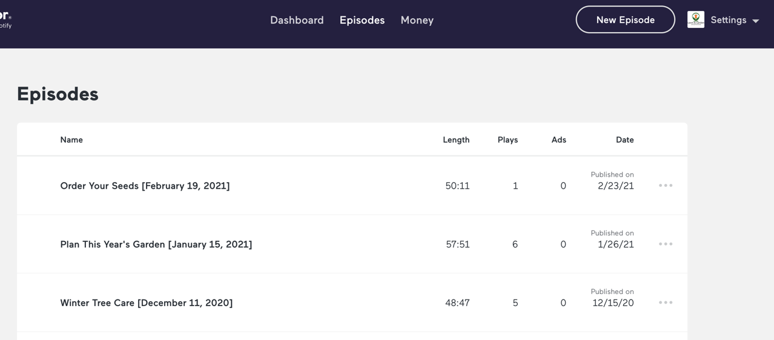

- Go to Settings > Update Settings to make account changes. You can upload or search for cover art here.
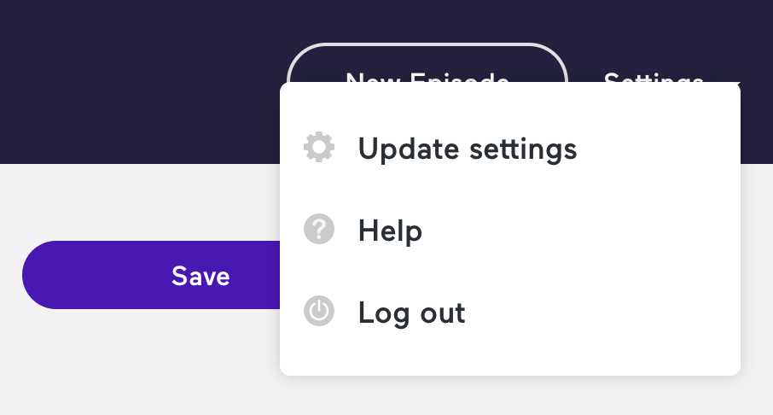

- Click Distribution to see where your podcast is shared. Your new podcast will automatically be added to Spotify (which owns Anchor) and a few other sites.
  - To add to Apple Podcasts you must have the same Apple ID as your Anchor login. Follow Anchor’s directions to connect accounts.
  - You can add the RSS feed to a website or social media.

