Adding Subtitles to Videos

Facebook:
- Go to your Page. This look may change with Facebook’s new interfaces.
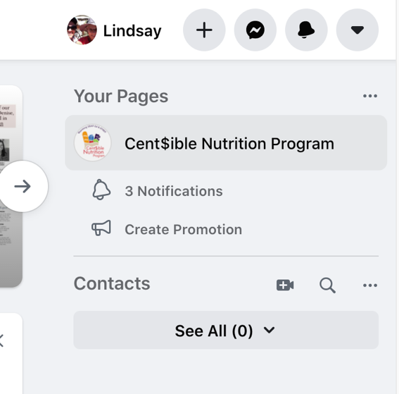

- Click Publishing Tools on left side list.
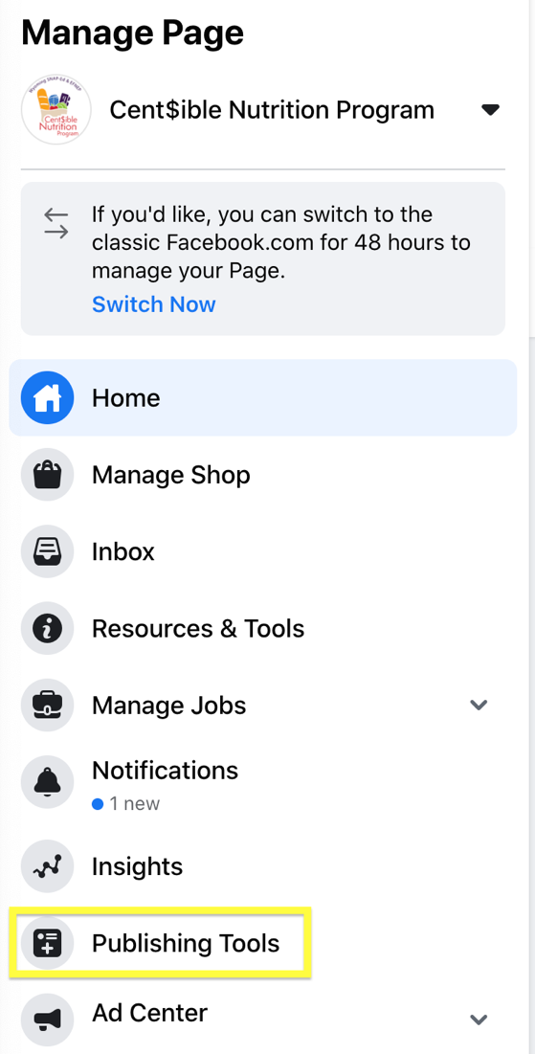

- The interface used to let you Publish/Schedule video posts with captions in the menu on the left, but now videos are all in the Creator Studio. You can access this by going to the Video Library.
  - [Upload videos directly to Facebook instead of linking from YouTube. Check captions on YouTube if you post there too.]
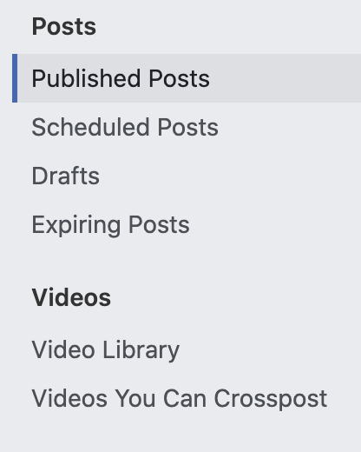
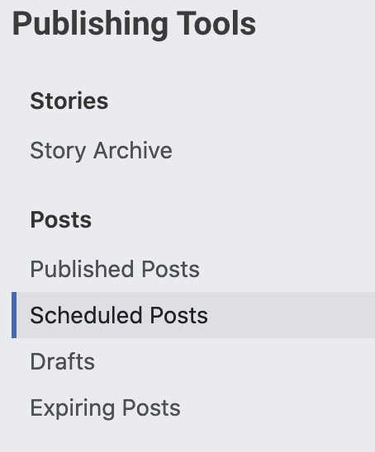

- Click “Upload Videos” in the top right corner. Choose one or more videos.
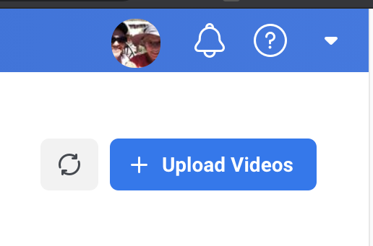

- Add Title, Description, Thumbnail, etc.
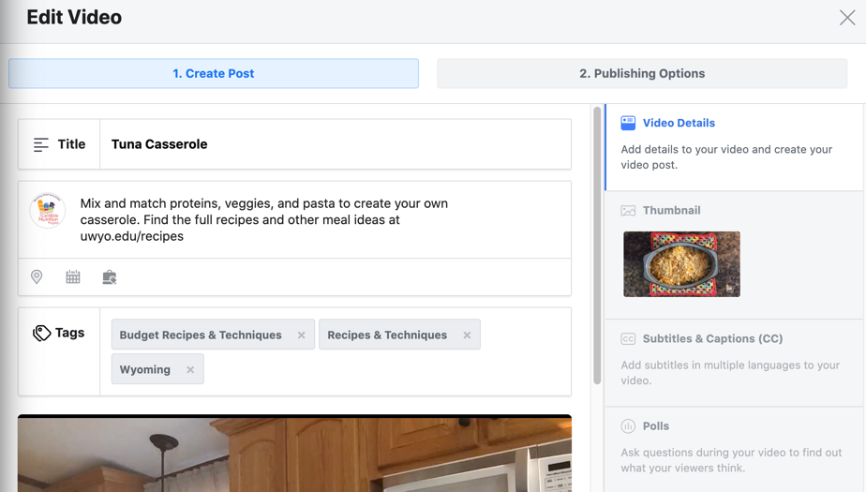

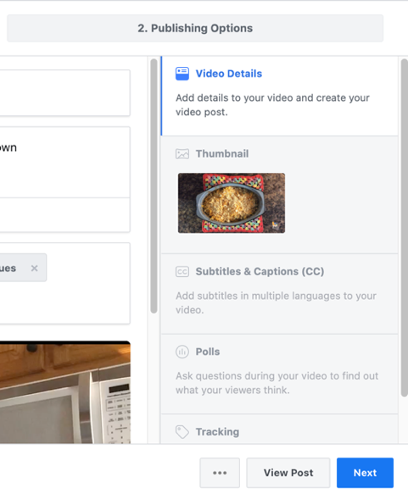
- Click Subtitles & Captions.

- Check box to autogenerate captions for each video or write captions yourself. Wait for autogenerated captions or Schedule/Publish post and return later to add/edit captions.
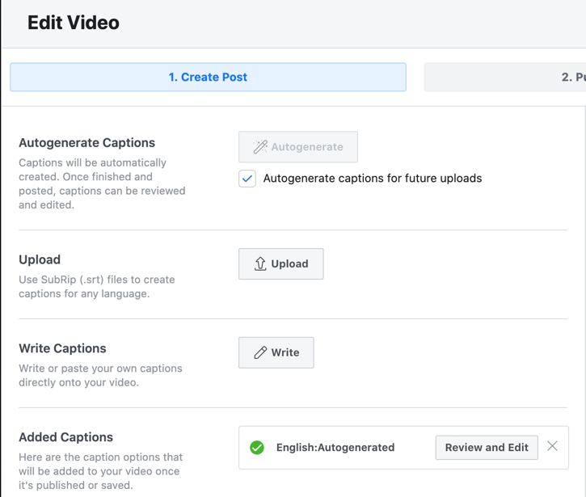

- Click Review and Edit when autogenerated captions are ready.
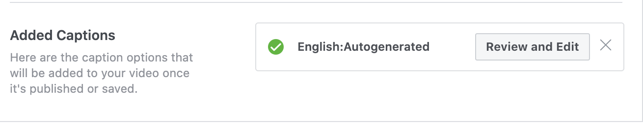

- Listen through video and edit captions as needed.
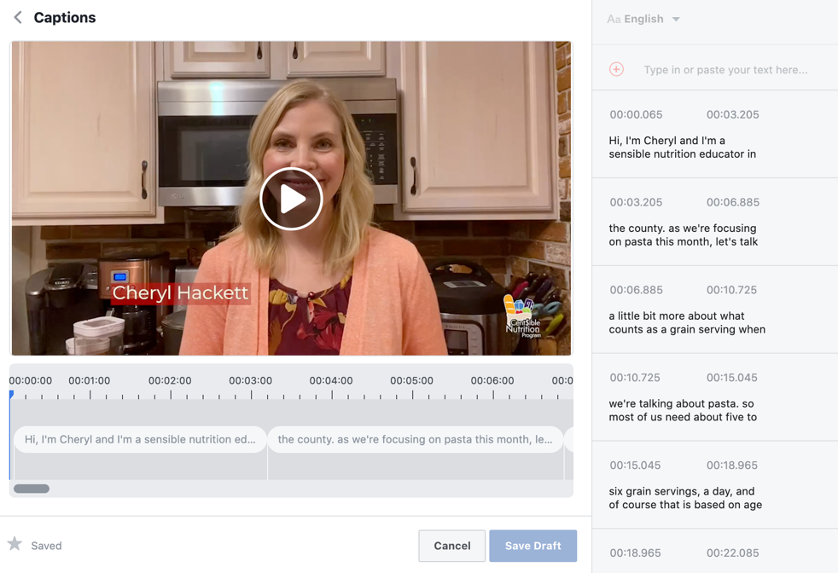

Captions are timed without gaps, so if you need to add a new row you have to change timing on an existing caption. Keep to Facebook’s format as much as possible as it follows ADA compliance fairly closely.

- Click Save Draft when finished.
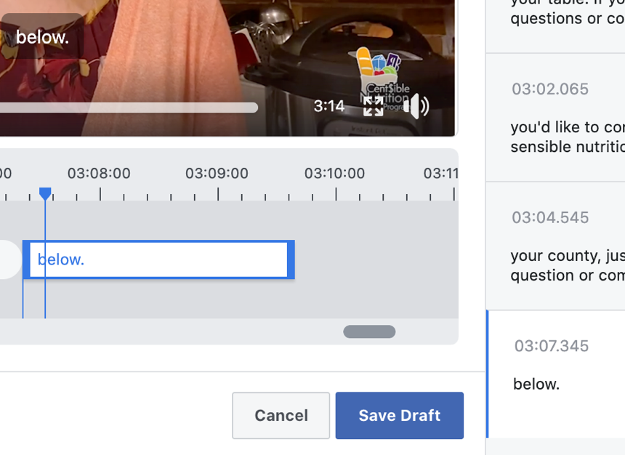

- Click through options on the post and make sure it’s still scheduled to post at the correct time.
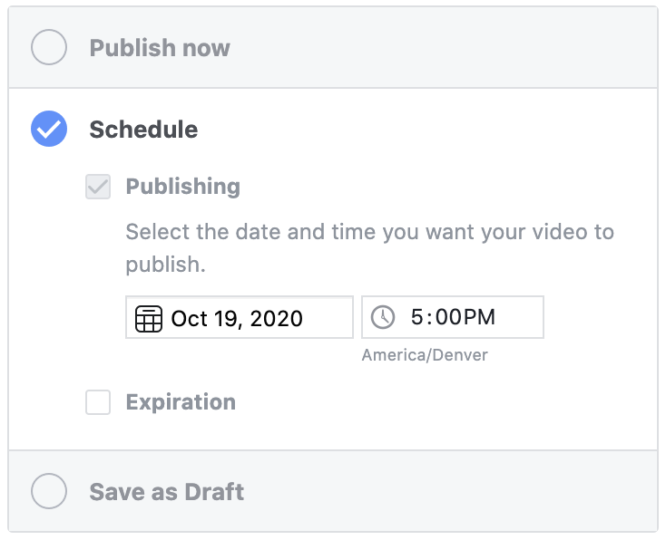

- If you need to make captions later or need to update them, navigate to the scheduled video in the Video Library (Creator Studio.) Click on video title that needs editing. The same video window will pop up. Editing captions uses the same process as creating them. Follow steps 5-11.

