Adding Subtitles to Videos

YouTube:
- Sign into YouTube.
- Click Account Icon in upper right corner.
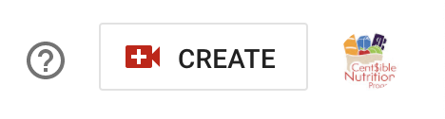

- Click Videos in left side list.

- Find video on right. Hover and click pencil to edit.
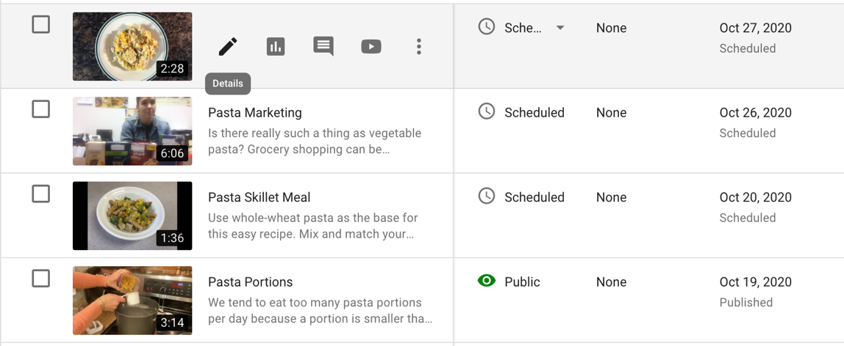

- Click Subtitles in left side list.
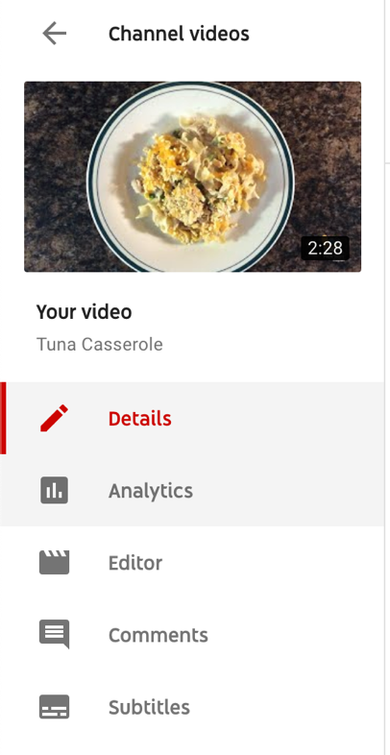

- If auto captions have been created click DUPLICATE AND EDIT. If auto captions have not been created, either wait until they are (could be 24 hours) or write them yourself.
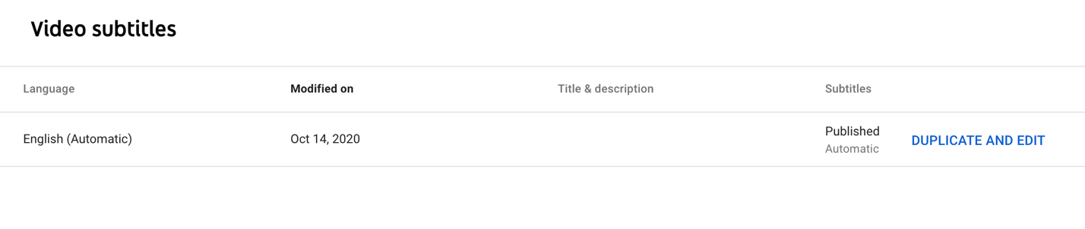

- Edit the block of text while listening to video. Check “Pause while typing” to make this easier.
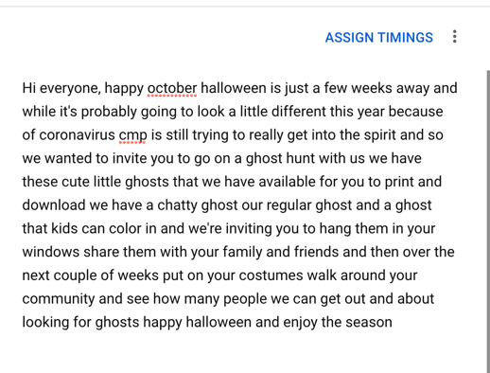
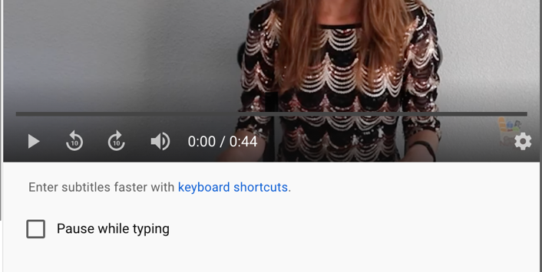

- Click Publish or Save Draft if you aren’t done.
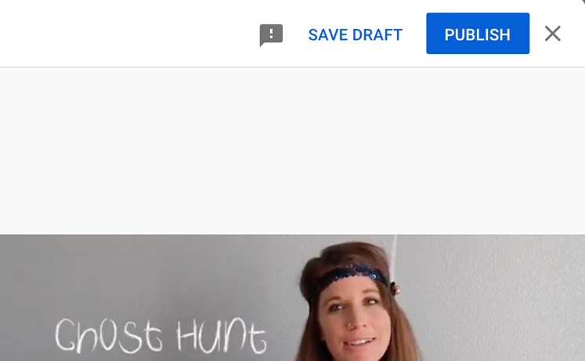

- Delete English (Automatic) file.
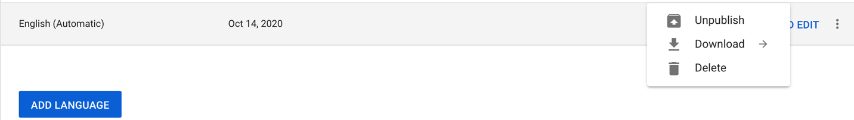

- Click Edit on English (video language) to check your work and ensure subtitles are generally well timed.
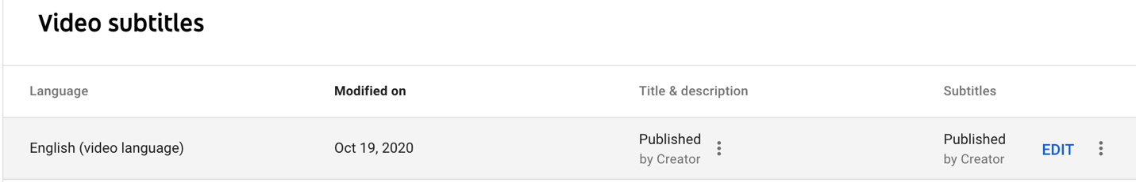

- Click Publish again to exit.

- Click back arrow to return to list of videos.
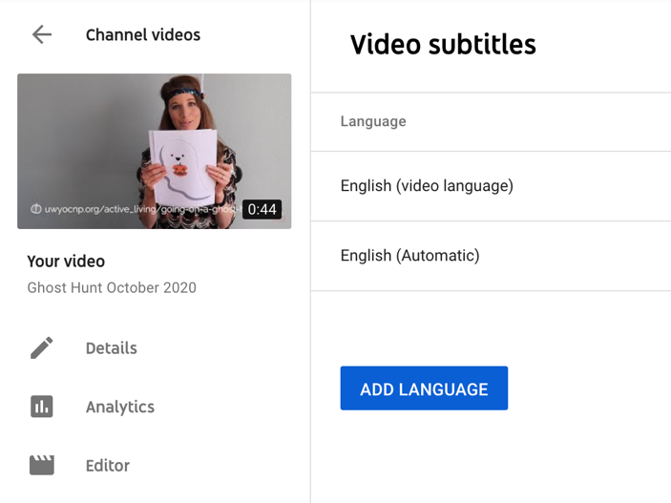

Download Subtitles File:
- Go to YouTube Studio > Content and click on the video you want captions for.

- Choose Subtitles on the left menu.
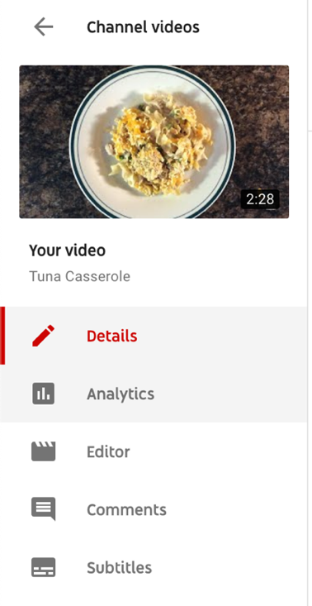

- Click the hamburger menu next to Edit.

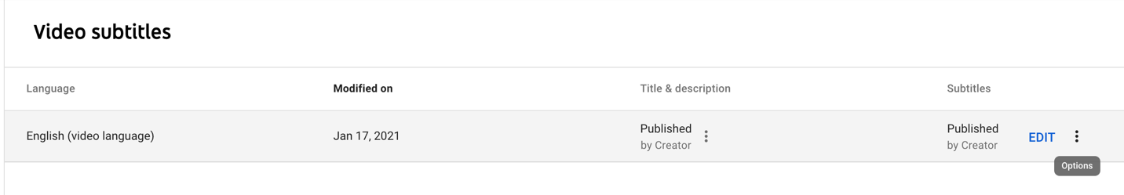

- Click Download > .srt
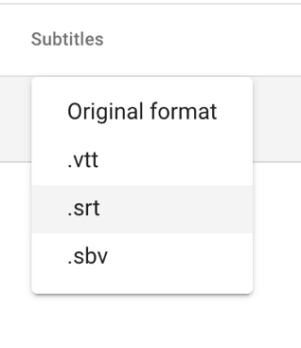
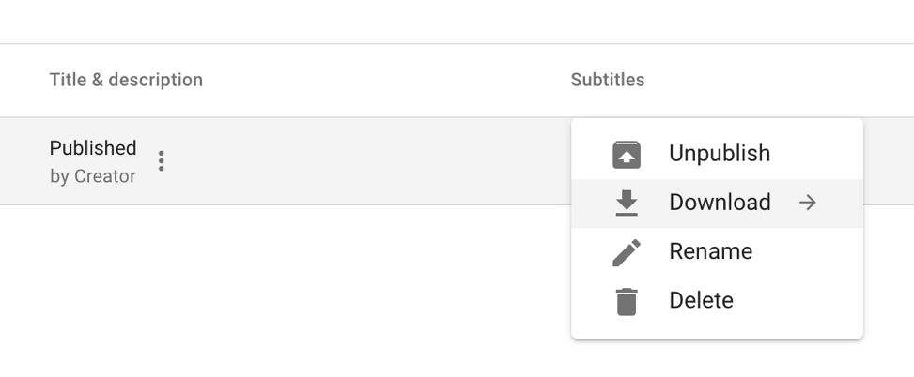
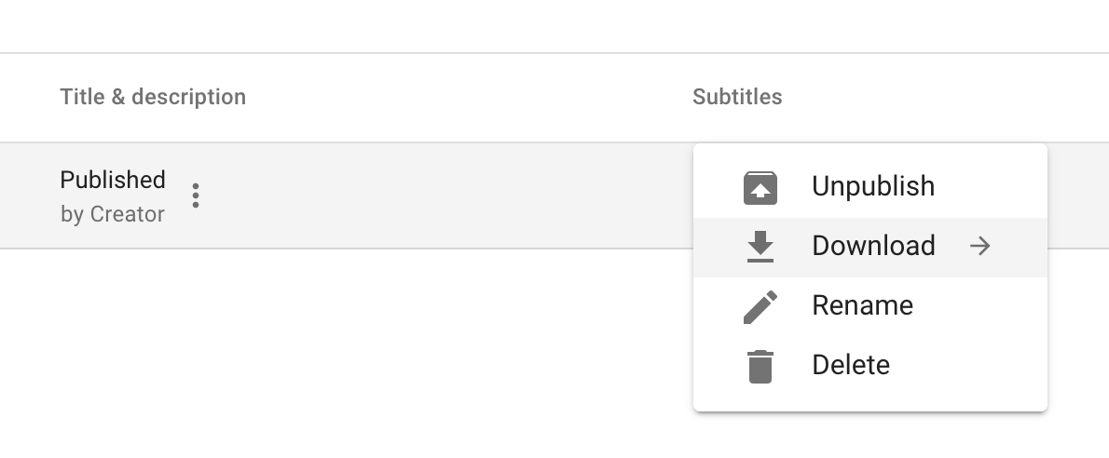

- Name the caption file with the same name as the video file. This will allow media players to recognize there is a caption file. Keep the captions file and video file in the same folder.

