Merge Videos in Windows 10 with Photos App

1.Open the Photos app and click on the Create button. Select the Video Project entry in the menu.
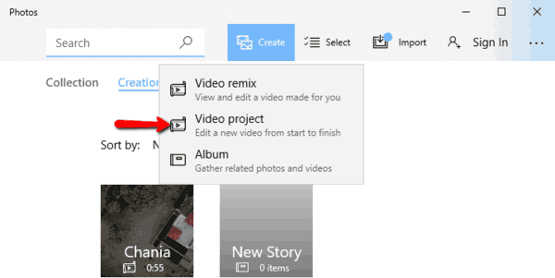

2. Select the video files you need to combine into a single file.

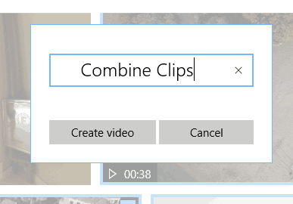
3. Name the project and click on ‘Create Video.’ The app will go to the video editor mode, where you can trim the added videos if needed. Click Done.

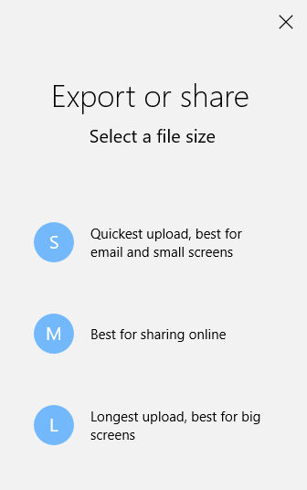
4. Click ‘Export or share.’

The video will be automatically saved to the folder “This PC\Pictures\Exported Videos.” This can take some time, depending on length of your clips. If you need to keep the original soundtrack for each video, ensure that you have selected “No Themes” under “Themes.”

