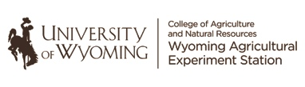

James C. Hageman Sustainable Agriculture Research & Extension Center

2753 State Hwy. 157

Lingle, WY 82223-8543