Mandated Reporting Guide for Child Abuse and Neglect  This brochure is designed to provide important information on reporting abuse and neglect in Wyoming.  Mandated Reporting Requirements  All citizens have a responsibility to protect those who cannot protect themselves. Wyoming state law (SS 14-3-205 & 35-20-103) mandates that any person who suspects child abuse or neglect is required to report regardless of their profession.  Wyoming is one of three states in which all residents are required to report suspected abuse. Abuse should be reported to the local Department of Family Services office or local law enforcement. If there is immediate danger, please contact law enforcement immediately or call 9-1-1.  When to Report  As a 4-H leader, employee or volunteer, you should report the following.  - Any direct observations of an incident or threat of child abuse or neglect  - Learning of an incident or threat of child abuse or neglect  - Reasonable cause to believe that child abuse or neglect has occurred or has the potential of occurring. |  | Child Abuse & Neglect  "Any recent act or failure to act on the part of a parent or caretaker, which results in death, serious physical or emotional harm, sexual abuse, or exploitation, or an act or failure to act which presents an imminent risk of serious harm."  (Child Abuse Prevention and Treatment Act, 42 U.S.C.A. § 5106g(2) (2003).) (CAPTA) |  | Protecting Our Youth
 |  |  |  | 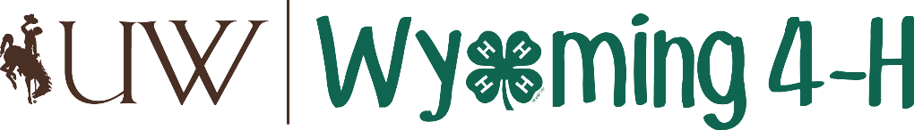

 |  | Signs of Abuse  - Aggression, with dangerous risk taking behaviors; disobedience; withdrawal  - Anxiety; depression; low self-esteem  - Extreme moodiness, or moods that are inappropriate for an activity or sudden changes in behavior  - Hypersensitivity to sudden or startling stimuli  - Fear of parents or other adults; fear of going home  - Suicidal thoughts  - Frequent absence from events/appointments  - Drug or alcohol abuse (particularly for older children)  - Frequent injuries  Important Contact Information  Mary Louise Wood, Albany County 4-H Educator  mwood8@uwyo.edu  307-721-2571  Albany County Sherriff  307-721-2526  Albany County Office  307-745-7324  If you are unable to find these numbers, you can always call 9-1-1! |  | “It is easier to build strong children than to repair broken men.”  Frederick Douglass
Types of Abuse  Physical: A non-accidental injury inflected on a child such as lacerations or fractures.  Emotional: Injury to the psychological capacity or emotional stability of the child as evidenced by an observable or substantial change in behavior, emotional response, or cognition, or as evidenced by anxiety, depression, withdrawal, or aggressive behavior.  Sexual: Sexual intercourse or sexual touching of a child, recording or displaying a child engaged in sexually explicit conduct, sexual exploitation, exposing of genitalia, forced viewing or listening to sexual activity, or permitting, allowing or encouraging a child to engage in prostitution. |  |  |  | Neglect  When a caregiver fails, refuses or is unable to provide necessary care, food, clothing, shelter, medical which endangers the health and well-being of the child.  Signs of Neglect  - Delays in physical development; Delays in cognitive development, such as speech disorders  - Constant hunger, tendency to overeat or hoard food; low weight; lack of medical care  - Inappropriate dress for the season; poor hygiene, dirty skin, matted hair  - Chronic, extreme fatigue

