2023 NATRONA COUNTY 4-H/FFA ALPACA OWNERSHIP I.D. CERTIFICATE

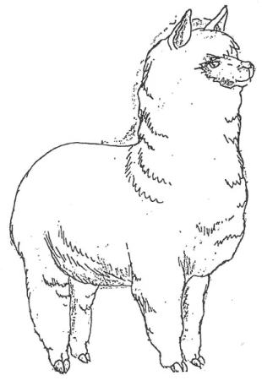
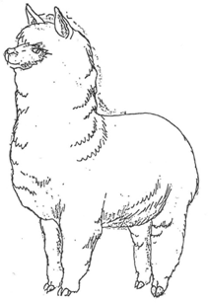
THIS FORM DUE BY JUNE 15, 2023

Member’s Name Common Call Name of Alpaca

Mailing Address Registered Name of Alpaca

City/State/Zip code Phone # Alpaca's Birthdate (MM/DD/YYYY) Male or Female

Owner’s Name Name of 4-H Club/FFA Chapter

Breed If registered, name and registration number of: Sire
Dam

Identification of Animal: ____________________________________________________________________
- Brands, color, markings, notches, scars, tattoos, etc. Identify as thoroughly as possible.

When was animal acquired for project (MM/DD/YYYY)?

When was animal in your possession for project (MM/DD/YYYY)?

FILED IN COUNTY OFFICE:

Member Signature Date
Parent/Guardian Signature FFA Advisor Signature

I certify that this is a 4H-FFA project this year and that the above information is correct to the best of my knowledge.

