2023 NATRONA COUNTY 4H-FFA GOAT OWNERSHIP I.D. CERTIFICATE

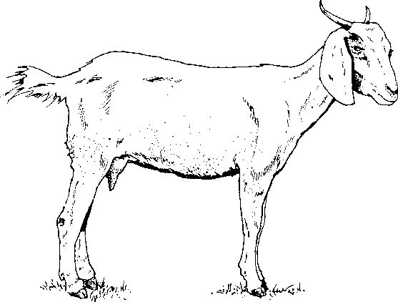
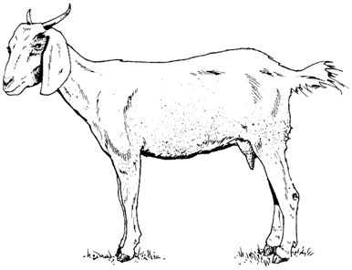
THIS FORM DUE BY JUNE 15, 2023

(Check One Below)
____ Breeding Market Goat
____ Dairy Goat
____ Pack Goat

If this is a registered goat, include copy of registration papers.

Member’s Name Common Call Name of Goat

Mailing Address Registered or Grade

City/State/Zip code Phone # Goat’s Birthdate (MM/DD/YYYY) Male or Female

Owner’s Name Name of 4-H Club/FFA Chapter

Breed If registered, name and registration number of: Sire
Dam

Individual Tag # Scrapies Tag Premise #

Identification of Animal: ____________________________________________________________________
- Brands, color, markings, notches, scars, tattoos, etc. Identify as thoroughly as possible.

When was animal acquired for project (MM/DD/YYYY)?

When was animal in your possession for project (MM/DD/YYYY)?

FILED IN COUNTY OFFICE:

Member Signature Date
Parent/Guardian Signature FFA Advisor Signature

I certify that this is a 4H-FFA project this year and that the above information is correct to the best of my knowledge.

