2023 NATRONA COUNTY 4-H/FFA CAT OWNERSHIP I.D. CERTIFICATE

THIS FORM DUE BY MAY 1, 2023
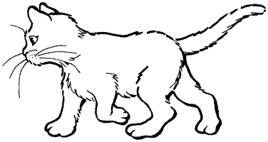

Member’s Name Common Call Name of Cat

Mailing Address Breed Variety

City/State/Zipcode Phone # Cat's Birthdate (MM/DD/YYYY) Male or Female

Owner’s Name (Required by State 4-H to be immediate family member) Name of 4-H Club/FFA Chapter

Registration Organization (If applicable) `

Registered Name of Cat (If applicable) Registration ID# (If applicable)

Identification of Animal: ____________________________________________________________________
- Brands, color, markings, notches, scars, tattoos, etc. Identify as thoroughly as possible.

When was animal acquired for project (MM/DD/YYYY)?

When was animal in your possession for project (MM/DD/YYYY)?

Date of Last Rabies Shot Date of Last Distemper Shot

*** Animal’s Health Record Must Be Attached. ***

FILED IN COUNTY OFFICE:

4-H Educator Signature Date

Member Signature Date
Parent/Guardian Signature 4-H Leader Signature

I certify that this is a 4-H project this year and that the above information is correct to the best of my knowledge.

