**2023 NATRONA COUNTY 4-H/FFA DOG OWNERSHIP I.D. CERTIFICATE**

# Form must be on file before attending clinics, attending classes, and/or participating in the 4-H Dog Show.

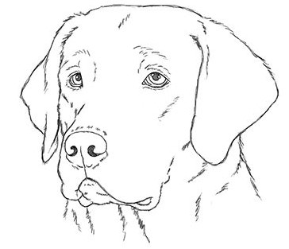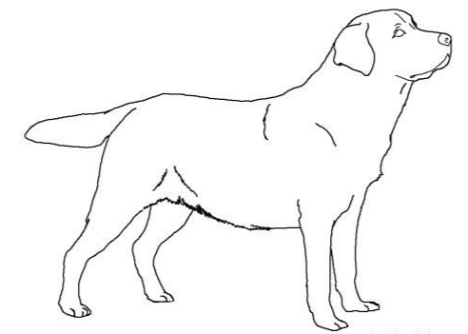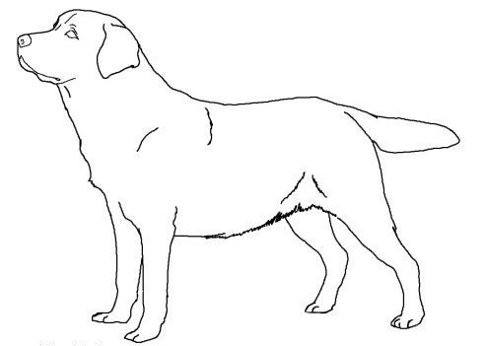

**Member’s Name Common Call Name of Dog**

**Mailing Address Breed Variety**

**City/State/Zipcode Phone # Dog's Birthdate (MM/DD/YYYY) Male or Female**

**Owner’s Name Name of 4-H Club/FFA Chapter**

**Registration Organization (If applicable) `**

**Registered Name of Dog (If applicable) Registration ID# (If applicable)**

**Identification of Animal: ____________________________________________________________________**

* **Brands, color, markings, notches, scars, tattoos, etc. Identify as thoroughly as possible.**

**When was animal acquired for project (MM/DD/YYYY)?**

**When was animal in your possession for project (MM/DD/YYYY)?**

**Date of Last Rabies Shot *** Animal’s Health Record Must Be Attached. \*\*\***

**Additional Notes: _________________________________________________________________________**

**4-H Awards Won: _________________________________________________________________________**

**Non-4-H Titles Earned: _____________________________________________________________________**

## We understand and agree to the following:

## The 4-H member will have sole responsibility of the training and competitive showing of this dog during the current 4-H year.

## Any infractions, as determined by a review committee, could disqualify the dog from showing or competing in any county or state 4-H contest.

**Member Signature Date**

**Parent/Guardian Signature Date**

## As the owner, I understand that I will not, nor anyone other than the youth listed above, compete with this dog.

## Owner’s Signature Date

## I certify that this is a 4-H project this year and that the above information is correct to the best of my knowledge.

***This page is for Office Use Only. Youth/Parents please don’t write on this.***

|  |  |  |  |  |
| --- | --- | --- | --- | --- |
| **Record of Obedience Scores** | | | | |
| Actual Height at Withers: | | | | |
| **Year** |  | **Obedience** |  | **Score** |
|  | | | | |
|  | | | | |
|  | | | | |
|  | | | | |
|  | | | | |
|  | | | | |
|  | | | | |
|  | | | | |
|  | | | | |
|  | | | | |
|  | | | | |
|  | | | | |
|  | | | | |

|  |  |  |  |  |
| --- | --- | --- | --- | --- |
| **Record of Agility Scores** | | | | |
| Measured Jump Height: | | | | |
| **Year** |  | **Agility** |  | **Score** |
|  | | | | |
|  | | | | |
|  | | | | |
|  | | | | |
|  | | | | |
|  | | | | |
|  | | | | |
|  | | | | |
|  | | | | |
|  | | | | |
|  | | | | |
|  | | | | |
|  | | | | |

|  |  |  |  |  |
| --- | --- | --- | --- | --- |
| **Record of Rally Scores** | | | | |
| Actual Height at Withers: | | | | |
| **Year** |  | **Rally** |  | **Score** |
|  | | | | |
|  | | | | |
|  | | | | |
|  | | | | |
|  | | | | |
|  | | | | |
|  | | | | |
|  | | | | |
|  | | | | |
|  | | | | |
|  | | | | |
|  | | | | |
|  | | | | |