NIOBRARA COUNTY 4H/FFA GOAT OWNERSHIP I.D. CERTIFICATE

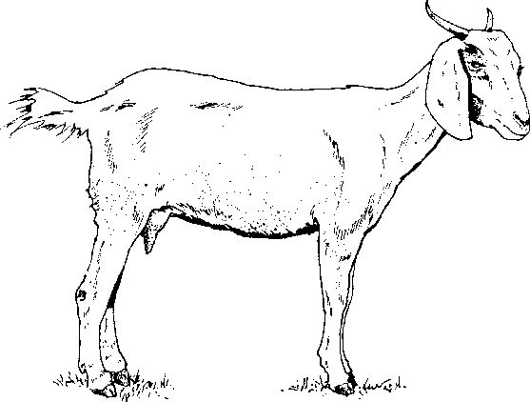
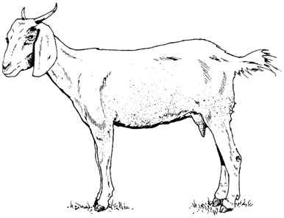
THIS FORM IS DUE BY JUNE 1 OF THE CURRENT YEAR

(Check One Below)
____ Breeding Market Goat
____ Dairy Goat
____ Pack Goat

Include one photo of full side right profile of animal AND one photo of full side left profile of animal.

Member’s Name Breed of Goat

Mailing Address Registered or Grade

City/State/Zipcode Phone # Goat’s Birthdate (MM/DD/YYYY) Male or Female

Owner’s Name Name of 4-H Club/FFA Chapter

Breed If registered, name and registration number of: Sire
Dam

Individual Tag # Scrapies Tag #

Identification of Animal: ____________________________________________________________________
- Brands, color, markings, notches, scars, tattoos, etc. Identify as thoroughly as possible.

When was animal acquired for project (MM/DD/YYYY)?

When was animal in your possession for project (MM/DD/YYYY)?

FILED IN COUNTY OFFICE:

Member Signature Date
Parent/Guardian Signature 4-H/FFA Advisor Signature

I certify that this is a 4H-FFA project this year and that the above information is correct to the best of my knowledge.

