Course Title:
Instructor(s):
Description:

Course Goals and Outcomes (see example):
Course Title:
Goals (broad) | Outcomes (measurable)

Example:
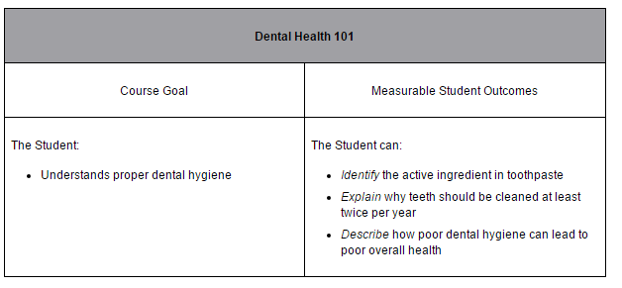Assessment.uconn.edu/primer/goals1.html
How will the course be delivered?
____ Online – asynchronous (no online meetings for students/instructor)
____ Online – synchronous (course occurs during online meetings only, no other work for students)
____ Blended – online only (students do work on their own time AND have scheduled online meetings)
____ Blended – online and face-to-face (students/instructor meet face-to-face AND do work online)

What technology must the instructor have and be able to use?

What technology must attendees have and be able to use?

Will any online meetings be recorded? If so, where will they be stored for later access?

How will attendee feedback about the course be collected? (online or paper survey, verbal discussion, etc.)

What, if anything, will attendees receive for completing the course?

Other possible issues or concerns:
____ Number of attendees
____ Educational materials
____ Scheduling (holidays, time of year, etc.)
____ Other

